BIO 40S – DNA TEST REVIEW

Key topics in the unit:
- Structure of DNA
- Protein Synthesis
- DNA replication
- Mutations
- Ethics

In order to be successful on the test, make sure you know:
- The differences between DNA and RNA
- The differences between amino acids and proteins
- How to read a DNA strand in protein synthesis (DNA→ mRNA→ tRNA→ amino acids)
- The steps involved in transcription and translation
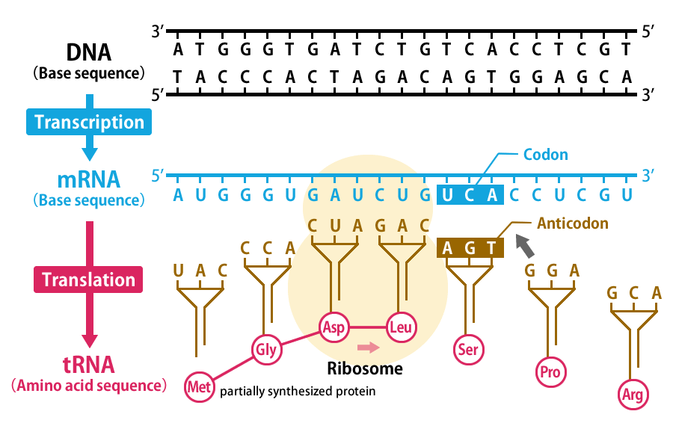
  - Where it occurs
  - How to read a codon chart
  - The difference between mRNA and tRNA
  - Base pairs

- How DNA replication works
  - Enzymes involved and what they do
  - Okazaki fragments
  - Differences between the leading and lagging strands
  - Directions of each strand
  - Diagram

- Types of mutations and how they affect protein synthesis
  - Point (3 types)
  - Frameshift (2 types)

- You will be required to answer an opinion-based question on the ethics behind DNA and genetics
