Gregor Mendel’s Genetic Discoveries:
A Scientific Creative Writing Project

Task
You are to assume the role of Gregor Mendel, having just formulated your conclusions
about the inheritance of traits. You are very excited about your findings and want to inform others of your findings. You will write an article (approx. 500 words) for publication in a science journal,describing your experimental results and conclusions. Keep in mind that it is the year 1866, and your audience consists of scientists who subscribe to the Proceedings of the Brno Society of Natural Science.

You may use the two readings provided as well as information found online to help with your article.

You will be given two classes in the computer lab to work on your project. After your first class (Feb 15) you need to print out anything that completed and hand it in to the sub. The assignment is due on Thursday, Feb 23.

Requirements
- Approximately 500 words, double spaced, size 12 font
- Two punnett square diagrams with explanations of how they work
- Accurate information with an original, creative writing style
- Title and date your article

Marking criteria
You will be marked in the following categories:
- Accurate information and language – 10 marks
- Explanation of punnett squares – 5 marks
- Mechanics (spelling, grammar, paragraphs) – 5 marks
- Originality – 10 marks

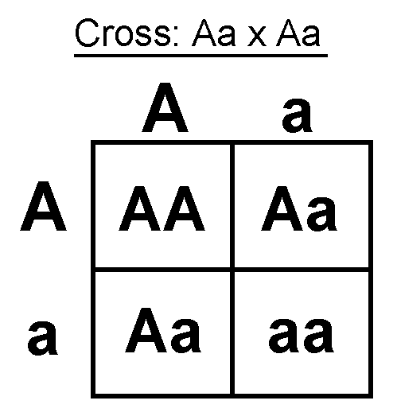

Gregor Mendel Writing Assignment
Name: __________________

Accurate Information | 0 1 2 3 4 5 6 7 8 9 10
Explanation of Punnett Squares | 0 1 2 3 4 5
Mechanics | 0 1 2 3 4 5
Originality | 0 1 2 3 4 5 6 7 8 9 10
Total | /30

Gregor Mendel Writing Assignment
Name: __________________

Accurate Information | 0 1 2 3 4 5 6 7 8 9 10
Explanation of Punnett Squares | 0 1 2 3 4 5
Mechanics | 0 1 2 3 4 5
Originality | 0 1 2 3 4 5 6 7 8 9 10
Total | /30

Gregor Mendel Writing Assignment
Name: __________________

Accurate Information | 0 1 2 3 4 5 6 7 8 9 10
Explanation of Punnett Squares | 0 1 2 3 4 5
Mechanics | 0 1 2 3 4 5
Originality | 0 1 2 3 4 5 6 7 8 9 10
Total | /30

