**How is Energy Transferred on Earth?**

**Energy Transfer on Earth**

* Most of Earth’s energy is in some way derived from the ________________.
* Even energy sources such as ________________ (energy from falling water) and ____________ can be traced back to the sun.
* 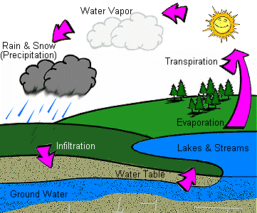**For example:**
* 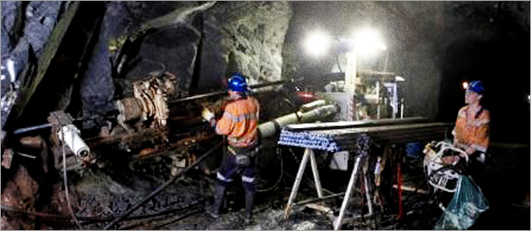 Hydro requires the water cycle which is driven by the sun
* Coal, oil, natural gases are made of what was once living material. (These either used the sun directly as an energy source, or ate organisms that did).
* There are really only a few ____________ sources of energy on Earth
* **e.g.** 🡪 **wind energy and geothermal energy**
* Food energy for the vast majority of ecosystems has as its source the ____________ ____________ activity of the ____________ in the ecosystem. There are one or two examples which do not use solar energy.

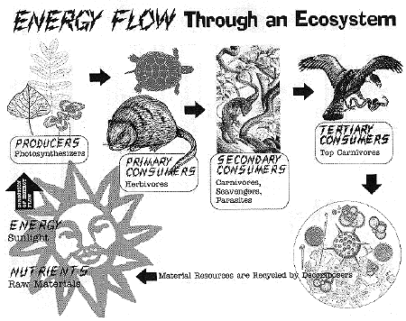

* “Black Smokers” diverse ecosystems surround the warm hydrothermal vents at the bottom of the sea, far away from any sunlight. Organisms here can use chemicals emitted from the vent for metabolism.

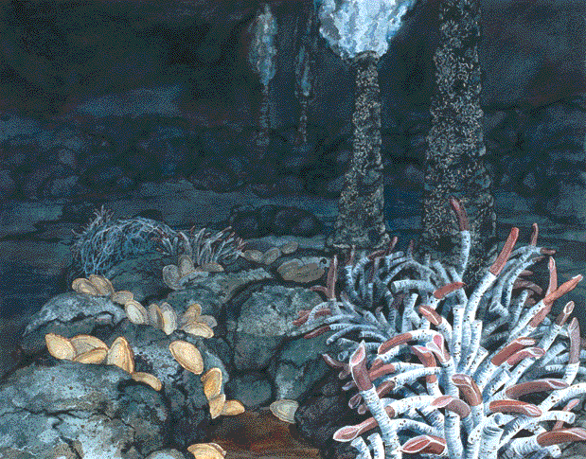

* Organisms metabolizing minerals deep within fissures in rocks.

**What is Energy?**

* Being that ecology is the study of the ____________ of nature, it makes sense that there should be some sort of ____________. This “currency” is E. (____________)
* Nature is governed by physical laws. Laws that concern the transfer of energy are known as the ________________________________________________.

**Laws of T.D.**

* *1) Energy exists in many* ____________.
* 2) Energy cannot be created or destroyed *but it can be* ____________. ***into different forms***
* 3) In all conversions of energy, some of the initial energy will be ____________ as ***heat or other unusable forms.***
* e.g. Chemical energy in animals: **can be converted into kinetic (movement) energy, as well as the energy needed to perform life functions.**
* **E.g. a cheetah uses its energy to create motion, but, excess heat is also produced in the process.**
* In an ecosystem, all of the energy that exists in the consumers____________ pass up the food chain to the next trophic level.

Due to:

* Some is used in life____________.
* lost as____________.
* ____________. material.

**10% Rule of Thumb**

* In fact, a rule called **the** ________________________can be applied to certain aspects of an ecosystem.
* **10% rule of thumb: Of all the energy residing in a certain trophic level (locked in chemical form in the tissues of organisms in that level) only** ____________.**will be passed to the** ________________________**.**
* The consequence of this is that there is a ____________amount of energy (stored as body tissue) the ____________ you climb in a food chain.

**Ecological Pyramids**

* Energy flow among the trophic levels can be described using a model created by ecologists.

**1) Pyramid of Numbers**

* Shows simply the ____________ of ____________.at each trophic level.
* These are the easiest for____________ to create
* These pyramids can be ____________.

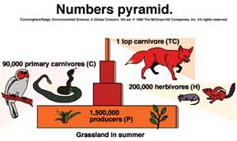

**2) Pyramid of Biomass**

* Shows the ____________ of each type of organism at each level.

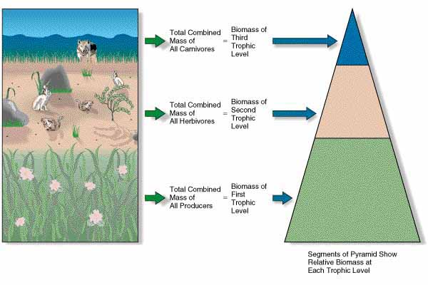

**3) Pyramid of Energy**

* Shows how much ____________ (measured in ____________) is at each level of the pyramid.
* Follows the 10% rule of thumb of energy transfer.

