NAME:_________________________________________ DUE DATE:__________________________

DOCTOR TRAINING: HEMATOCRIT
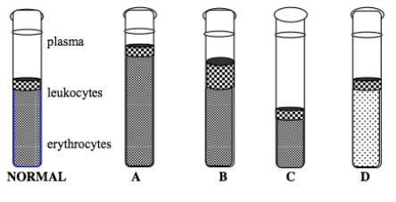
1. Determine the normal hematocrit by using the following formula:
𝑟𝑒𝑑 𝑏𝑙𝑜𝑜𝑑 𝑐𝑒𝑙𝑙 𝑣𝑜𝑙𝑢𝑚𝑒
𝐻𝑒𝑚𝑎𝑡𝑜𝑐𝑟𝑖𝑡 = ∗ 100
𝑡𝑜𝑡𝑎𝑙 𝑏𝑙𝑜𝑜𝑑 𝑣𝑜𝑙𝑢𝑚𝑒

- Calculate and record the hematocrit of the normal subject. [2 PTs]

- Calculate and record the hematocrit of person A, B, C and D. [8 PTs]

2. A device called a hemacytomater is used to measure the amount of hemoglobin present. Red blood cells have the ability to concentrate hemoglobin to about 34 g/100mL of blood. Readings below 15 g/100mL of blood indicate anemia. Blood appears pale if hemoglobin levels are low.
Which subject (A,B, C or D) has a low level of hemoglobin? Explain. [3 PTs]

- Cancer of the white blood cells is called leukemia. Like other cancers, leukaemia is associated with rapid and uncontrolled cell production.
Which subject (A,B, C or D) might be suffering from leukemia? Explain. [3 PTs]

- Although hematocrits produce some information about blood disorders, most physicians would not diagnose leukaemia on the basis of one test.
What other conditions might explain the hematocrit reading you chose for answer d? Explain? [3 PTs]

- Lead poisoning can cause bone marrow destruction.
Which of the subjects might have lead poisoning? Explain. [2 PTs]

Which subject lives at a high altitude? Explain. [2 PTs]

- Recently, athletes have begun to take advantage of the benefits of extra red blood cells. 2 weeks prior to a competition, a blood sample is taken and centrifuged and the red blood cell component is stored. A few days before the event, the red blood cells are injected into the athlete.
Why would athletes remove blood cells only to return them to their body later? [2 PTs]

- A physician notes fewer red blood cells and prolonged blood clotting times in a patient. White blood cell numbers appear to have increased, but further examination reveals that only the granulocyte numbers have increased, while the a granulocytes have decreased. In an attempt to identify the cause of the anomaly, the physician begins testing the bone marrow.
Why did the physician suspect the bone marrow? [2 PTs]

Predict what might have caused the problem. [2 PTs]

- Individuals who work in a chemical plant are found to have unusually high numbers of leukocytes. A physician calls for further testing.
Hypothesize about the physician’s reasons for concern. [2 PTs]

Why might the physician check both bone marrow and lymph node areas of the body? [2 PTs]

